# **SMART PARKING SYSTEM**

IoT Smart Parking project, it can enhance the functionality and user experience by incorporating web development technologies. Here's how can integrate web technologies into various aspects of the project:

**1. Web-based Dashboard for Administrators:**

Create a web-based dashboard for administrators to monitor and manage the parking system. This dashboard should provide real-time information about parking spot occupancy, reservations, and transaction history. Use web development technologies like HTML, CSS, and JavaScript, and consider using a web framework for efficiency.

**➢HTML/CSS:** Design the dashboard's layout and style using HTML and CSS.

**➢JavaScript:** Implement interactivity for real-time updates, charts, and user management.

**➢Web Framework:** You can use popular frameworks like React, Angular, or Vue.js for a more organized and responsive interface.

**2. Mobile App:**

Develop a mobile app to reserve parking spots, make payments, and receive notifications. Use cross-platform mobile app development frameworks like React Native or Flutter to streamline app development for both Android and iOS.

**➢React Native or Flutter:** Build the app's frontend using these frameworks, which allow you to write code once and deploy it on multiple platforms.

**➢API Integration:** Connect the app to the backend server for user authentication, reservation processing, and payment handling.

**3. Online Reservation System:**

Implement a web-based reservation system for students to check parking spot availability and make reservations. This system can be integrated with the mobile app and can be developed using standard web technologies.

**➢HTML/CSS:** Design the reservation interface.

**➢JavaScript:** Develop interactive features, such as selecting a parking spot and specifying the reservation duration.

**➢Backend:** Implement reservation logic on the server side, making use of frameworks like Express.js (Node.js) or Django (Python).

**4. Payment Gateway Integration:**

If you include a payment system, you'll need to integrate a payment gateway into your web app for processing payments. Popular payment gateways often provide APIs for this purpose. Here's a simplified example using Python and Flask:

**➢Flask:** Create an API endpoint to handle payment requests.

**➢Payment Gateway API:** Utilize the API provided by the payment gateway provider (e.g., Stripe, PayPal) for processing payments.

**➢Frontend Integration:** Integrate the payment process into your mobile app or web app, allowing users to enter payment details securely.

**5. Real-time Updates:**

Use web development technologies to ensure real-time updates on parking spot availability, reservation confirmation, and payment status. You can achieve this with technologies like WebSocket for real-time communication between the server and clients.

**➢WebSocket:** Implement WebSocket communication to push real-time updates to the web and mobile clients when a parking spot's status changes.

**6. User Authentication and Management:**

For user authentication and management, you can create user registration and login systems within the mobile app and web interface. Use web development technologies for user interfaces and backend logic:

**➢HTML/CSS:** Design registration and login forms.

**➢JavaScript:** Implement form validation and submission handling.

**➢Backend:** Create user accounts, manage authentication, and store user data securely in a database.

**7. Data Analytics and Reporting:**

Utilize web technologies to create data analytics and reporting features for administrators. You can use JavaScript libraries for data visualization and reporting tools.

**Data Visualization Libraries:** Integrate libraries like Chart.js or D3.js to display parking utilization statistics and trends.

**Backend:** Develop APIs for fetching historical parking data and generating reports.

**Mobile App Development**

To connect your IoT Smart Parking System with a mobile app, you need to create APIs that allow the mobile app to interact with the backend system. Here's a step-by-step guide on how to achieve this:

**1. Develop Backend APIs:**

➢Create a set of API endpoints on your server to handle various functionalities of the Smart Parking System, such as user authentication, parking spot availability, reservations, and payments. You can use a web framework like Express.js (Node.js) or Django (Python) to develop these APIs.

**2. User Authentication:**

➢Allow users to register and log in to the mobile app.

➢Create API endpoints for user registration and login.

➢Implement token-based authentication for secure access to the app.

**3. Parking Spot Availability:**

➢Develop an API endpoint to provide real-time information about parking spot availability.

➢The mobile app can query this endpoint to display available parking spots to users.

**4. Reservations:**

➢Create APIs for reserving parking spots. When a user selects a spot and reserves it, the mobile app should send a request to the reservation API.

➢Implement logic to check spot availability and confirm the reservation.

➢Return a response to the mobile app with the reservation status.

**5. Payment Integration:**

➢Integrate payment gateway APIs, such as Stripe or PayPal, for processing payments.

➢Create API endpoints for initiating and verifying payments. The mobile app can call these endpoints to handle payments.

**6. Real-Time Updates:**

➢Implement WebSocket communication to provide real-time updates on parking spot availability and reservation confirmation. When a parking spot becomes available or a reservation is confirmed, use WebSockets to push updates to the mobile app.

**7. Mobile App Development:**

➢Develop the mobile app using a cross-platform framework like React Native or Flutter to ensure compatibility with both Android and iOS.

➢Implement user interfaces for registration, login, parking spot selection, reservations, and payment processing.

**8. API Integration:**

➢Use HTTP requests (e.g., GET, POST, PUT, DELETE) in the mobile app to communicate with the backend APIs.

➢Handle API responses in the app to update the user interface and provide feedback to the user.

**9. User Notifications:**

➢Implement push notifications to notify users of reservation confirmations, payment status, and other important updates.

➢Utilize Firebase Cloud Messaging (FCM) for Android and Apple Push Notification Service (APNs) for iOS.

**10. Testing and Debugging:**

➢Test the mobile app's functionality by creating test scenarios and debugging any issues that arise.

➢Verify that the app can interact seamlessly with the backend APIs.

**11. Deployment:**

➢Deploy the mobile app to app stores (Google Play Store and Apple App Store) for public use.

**12. User Support and Updates:**

➢Provide ongoing support and maintenance for the mobile app.

➢Implement updates as needed, addressing user feedback and making improvements.

By creating a well-designed set of APIs and integrating them into mobile app, that can establish a robust connection between the Smart Parking System and the mobile app, ensuring a seamless and user-friendly experience for students.

**Program:**

Creating a mobile app for an IoT Smart Parking System is a complex task that requires a significant amount of code and development effort. I can provide you with a simplified example of framework to create a basic user interface for a mobile app. Please note that this example is a basic starting point, and it would need to extend it significantly to implement the full functionality of the Smart Parking System.

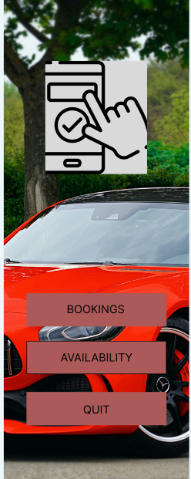

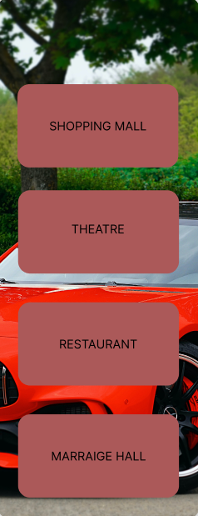

The above templates are the designed for creating IOT based smart parking app with the combination of Figma, flutter to make front end to the project.

Where Figma is design software for Ui/UX designer to design the basic work in the interface and also which is linked with the flutter with extension. Flutter is an app development software, which is used to create an app for IOT .

With the help of these frame work interface for an IOT project is develped.